Harmonic Analysis Tools

Purpose
This module offers a set of functions for harmonic analysis and composition of time series. These functions are:
- Harmonic analysis; this allows the user to calculate harmonics for time series up to a maximum harmonic
- Harmonic composition; this is the reverse operation. Calculate the reconstructed time series.

Installation
Install the .sav files in the save_add folder (see also ENVI .sav files: Installation and configuration.
_nrsmenu.sav Define NRS menu item in ENVI
nrs_Utils.sav Library with utility routines
nrs_harmonic_analysis.sav The actual software

Usage (gui)
nrs_harmonic_gui | Start the user interface of the harmonic analysis.
nrs_harmonic_inv_gui | Start the user interface of the harmonic composition.
Alternatively the commands can be started from the ENVI menu: ‘NRS | NDVI’:
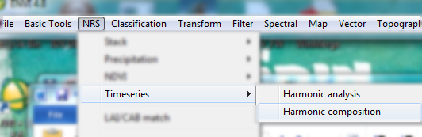

Harmonic Analysis
Menu option is ‘NRS | Timeseries | Harmonic analysis, the command line is ‘nrs_harmonic_gui’. This function calculates the harmonic decomposition of a time series using FFT. The decomposition is done in slices of one year and generates a decomposition for each year.
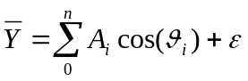 (1)
For example the VCI (Vegetation Condition Index) is calculated with formula (1), while the TCI (Temperature Condition Index) is calculated with formula (2).
The user interface is shown below:
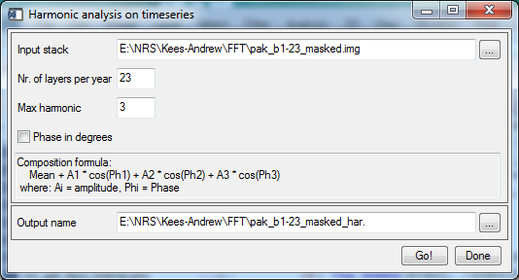
Explanation of all the fields:
Input series | Select an input NDVI time series;
Normalize over entire series | If selected the minimum and maximum values are calculated over the entire series, before applying the normalization formula.
Normalize per year | If selected the minimum and maximum values are calculated per year and the normalization is restarted for each year. This version of the software assumes 36 NDVI images per year.
Output in percentages | If switched on will calculate the index as a percentage by multiplying the index with 100%
Normalize over minimum | Use formula (1)
Normalize over maximum | Use formula (2)
Output series | The filename of the output time series.

Drought index
Menu option is ‘NRS | NDVI | Drought index, the command line is ‘nrs_drought_gui’. The drought index is defined as :
(3)
The user interface is shown below:
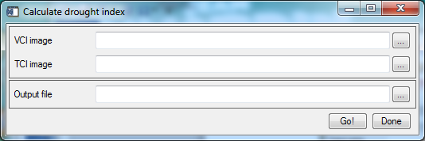
Explanation of all fields:
VCI image | Select the VCI
TCI image | Select the TCI image
Output file | The filename of the output file.

References:
Kogan, F. N. (1995). "Application of vegetation index and brightness temperature for drought detection." Advances in Space Research Vol. 15(11): 91-100.

